Abstract Template. Title (using Times New Roman Font, 14 pt, Bold, Centered)

First Author¹, Another Author², …, Underline Presenting Author^{N}

¹Institution name, address, using italic Times New Roman font, 11 pt, centered
²Another institution name different from the first, another address
N=the number of unique institutionsYet another institution name, another address

Email: correspondingauthor@timesnewromanfont.11pt.centered

Please conform to the abstract format presented in this template, particularly the A4 paper type and margins [1]. Use MS Word or LibreOffice and limit yourself to one page. There should be a 12 pt blank line separating the title and author list, a 4 pt blank line between author list and affiliations, an 8 pt blank line between author list and email of the corresponding author and a 12 pt blank line between the email address and start of the main body of text. The author list should be centered, using 12 pt Times New Roman font. The main text, acknowledgements and references, if any, should be in Times New Roman font, 11 pt, with full justification. Photoemission spectroscopy and microscopy are undergoing a rapid transformation driven by major advances in spatial, temporal, energy, and momentum resolution. These developments have opened new possibilities for visualizing ultrafast dynamics, nanoscale phenomena, and electronic structures with unprecedented precision. Beyond traditional applications in physics and chemistry, photoemission techniques are increasingly influencing fields such as quantum materials research, semiconductor technology, energy devices, and even emerging areas like biological imaging. This workshop will highlight recent breakthroughs in photoemission-based microscopy and spectroscopy, showcasing cutting-edge instrumentation and cross-disciplinary applications. By bringing together experts in fundamental science, applied research, and technology development, the meeting aims to spark new collaborations and perspectives.
The central focus of this workshop is the active participation of early-career researchers and students. Through presentations, discussions, and networking opportunities, the event will support the next generation of photoemission scientists and promote long-term international collaboration. Overall, the workshop seeks to chart the future of photoemission science as a powerful tool for discovery and innovation across multiple scientific and technological domains.

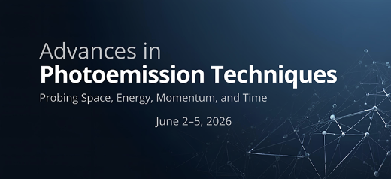

Figure 1. Use 10.5 pt Times New Roman font with full justification.

Acknowledgement
Here you can acknowledge funding and/or other important contributions to this work.

References
[1] Margins are set to 27.9 mm (1.1”) on the right and left and 25.4 mm (1”) on the top and bottom.
[2] A. Author, B. Author, and C. Author, Phys. Rev. B 99, 123456 (2018).
[3] References: Physical Review B format, Times New Roman, 11pt, volume bold.

