Transcript:
Thank you for your interest in borrowing the eDNA sampler from the Environmental and Informatics Section. Here, we will go over how to use the sampler in a manner that is safe for both the user and the sampler.
**About the eDNA sampler**
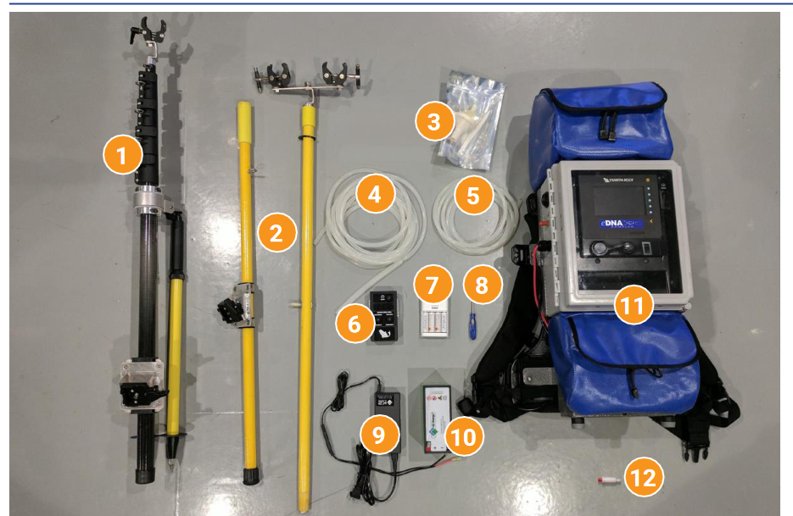
The eDNA sampler includes the following features.
Telescoping sampling pole with support bipod for sampling far to reach areas.
Transect sampling pole for mobile sampling. This pole allows you to move while you take samples and take 3 samples at the same time. It can’t reach as far as the Telescoping pole.
Intake hose with backup filter.
Outtake hose
Rechargeable 12v DC battery for eDNA sampler unit. This battery is a sealed lead battery and must not be heated above 50C for risk of fire. Avoid putting the battery in situations where it could get wet.
Your filter. Filters for taking samples will not be provided by the ESI section. You can purchase either self-preserving filters or non-self-preserving filters.
**eDNA sampler body**
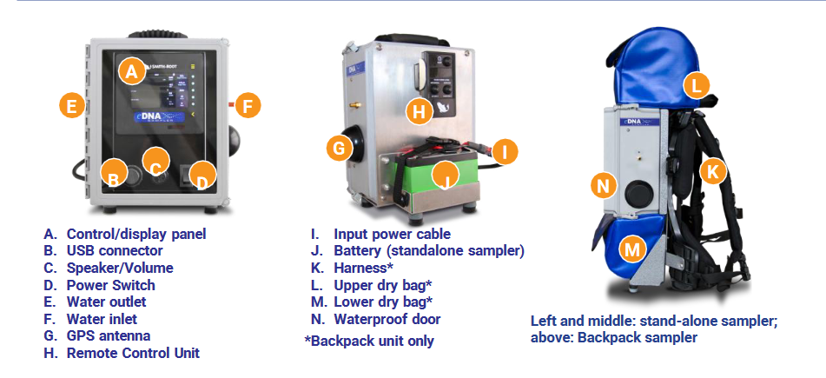
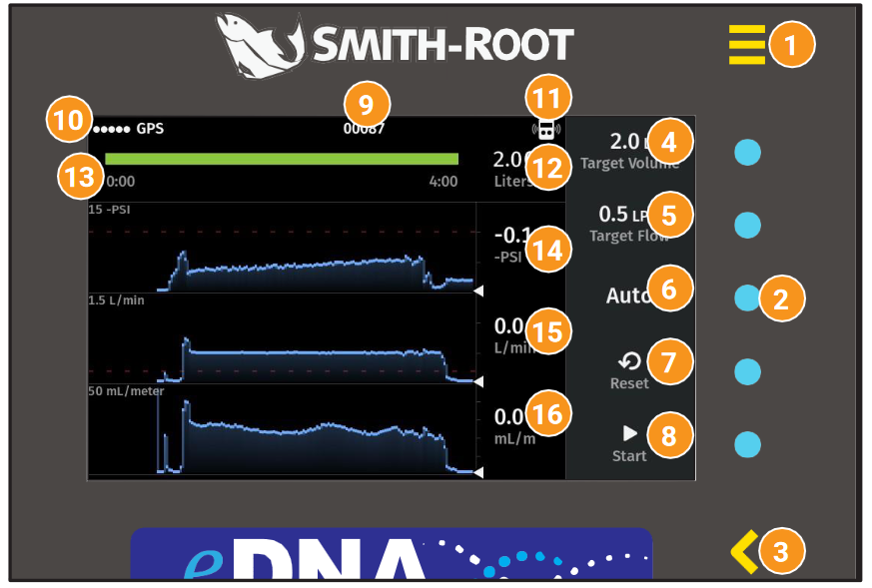
This is the eDNA sampler. This is the control and display panel, where you can set and monitor your flow rate in L/min, target sample volume, current pressure value, and current transect rate (filtered volume per unit distance (ml/m).
The machine has a USB port to allow you to take data of your sampling events and store it onto a flash drive as a csv file. Simply put your USB in and the machine will automatically move the data for you. Wait until it gives you the indication that it is finished.
Water intake
Water outtake
GPS antenna
Battery connection. Simply connect like colors together and place the battering in the bottom compartment so it is resting inside the metal frame.
Upper dry bag, lower dry bag.
Waterproof door. While taking a sample and when not actively using the menu screen make sure that the door remains closed to prevent water or other forms of damage.

**Warnings before use**
Before taking the sampler into the field you must be aware of the following safety warnings. Do not crimp or clamp the OUT tubing or it will cause damage to the machine and pump.
Do not allow prolonged exposure to sunlight on the display electronics.
Do not allow the machine to be in freezing conditions.
Make sure to attach the intake hose to the IN port. The intake hose has a secondary filter that should never be removed. This filter acts as a failsafe in case sand or debris gets sucked up accidentally. Do not allow sand or debris to enter the machine as it will cause damage.
Wear proper PPE
Do not apply suction hose to skin.
If the battery has a cracked case or looks faulty, immediately stop use of the battery and not touch it until it can be disposed of properly. Do not use the battery if you suspect it has been damaged in any way.
**Preparing to use the eDNA sampler in the field**
Either in preparation or in the field, before you take your samples you want to decide your settings. You can press the buttons to set your desired settings. Keep in mind that if your filters are too fine and your sample water is too bioactive the sampler may be unable to sample large quantities of data.
If you have a desired sample volume, you can set the sampler to auto mode and set the volume offset. Auto mode will beep 2 times to alert you to invert the hose to achieve the target sample volume. The volume offset will change when you change hoses or poles.
Manual mode will not alert you to any specific sampling amount. This is useful for when you don’t know how much water you want to sample, or you are regularly starting and stopping the sampler.
The sampler has a maximum pressure of 10.0 PSI and if it reaches this limit the pump will be throttled. Your minimum flow rate is 0.2 L/min to which the sampler will alarm.
**How to use the eDNA sampler**
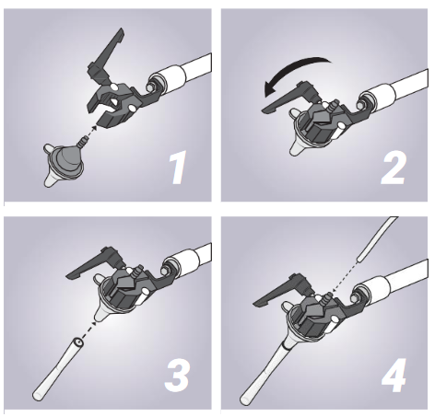
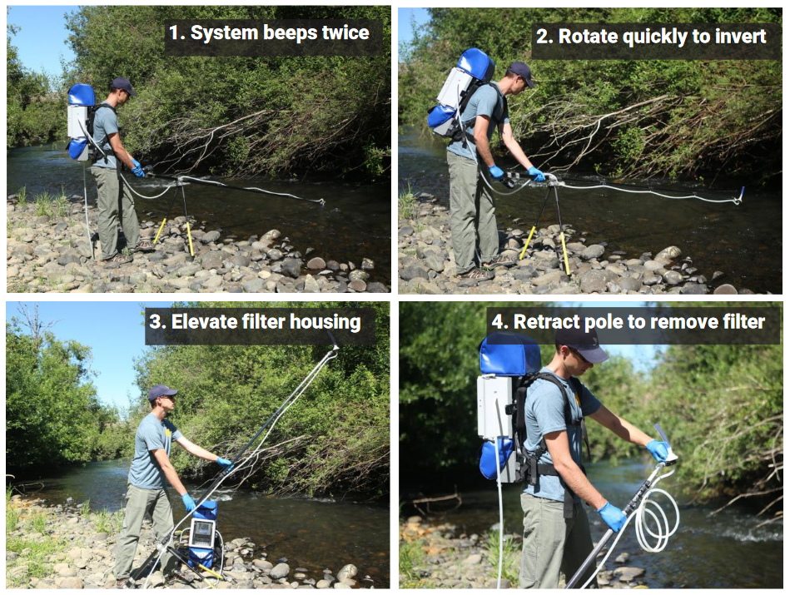
In preparation check that the batteries are fully charged before going out. Check that you have everything before you leave and attach the battery to the power source. Transport the backpack to your sampling location as is.
When you reach your sampling location, attach your filter to your selected pole. First, tilt the pole upside down and open your filter packet. To avoid human contamination, it is recommended to use gloves when handling the filters. Secure the top part of your filter into the clamp and secure the nozzle to the bottom.
Connect the intake hose from your desired pole to the IN port and the outtake hose to the OUT port. Lay the end of the outtake hose anywhere away from the backpack.
Dip your filter extension into the water deep enough that air won’t get inside but not so deep that the body of the filter is submerged. If your body is deep enough and accessible enough to sample directly you can sample directly from the water source, but if the water source is out of reach or is too shallow, you can make use of a bucket or other container.
Once your filter is secured in the water have your partner turn on the machine and press start. The sampler will begin pulling up water. When you have reached your desired amount of water, quickly flip your pole upside down so the filter nozzle points to the air. Allow air to run all the way through the sampler. This also allows you to clear the tubes and dry your sample. For self-preserving samples, crack the seal and allow the filter to dry for 20 seconds. Be careful not to open the filter completely.
When finished remove the filter from the pole clamp and store it back into its bag. Self-preserving filters can be kept unrefrigerated for up to 6 months. When you return to the lab you can remove your sample from the filter, by opening the container and removing the filter paper. This paper is your DNA sample.
**How to take a sample while walking**
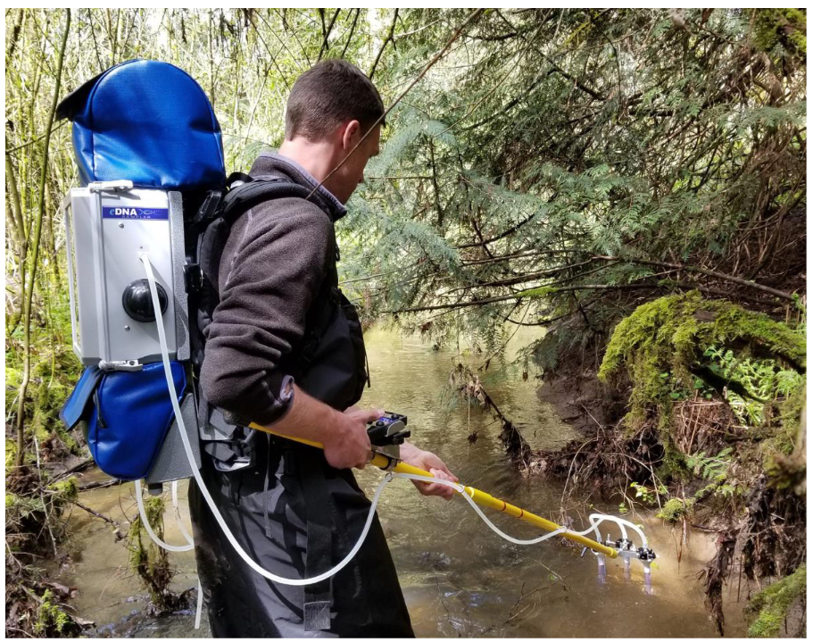
The specialty of this eDNA sampler is that you can take samples while you walk along the water source. The transect pole is better designed for this kind of sampling method. If your water source has obstructions or shallow regions that will require you to lift your filters from the water it is not recommended to use the self-preserving filters. The self-preserving filters may have trouble pulling water back up if their extenders are emptied fully.
Manual mode will allow you to track the total amount of water that was pumped even if you have to stop and restart the machine several times while sampling.
Attach your filters and place the filter extensions in the water. Once you press start you can begin. sampling from downstream to upstream. Try to keep a consistent pace when walking.
When an obstruction is encountered, press the Start/Stop button to stop the pump, but leave the extension tubes in the water. Quickly rotate the pole and invert the filter housings, retaining as much water in the extension tubes as possible. Move around the obstruction to the next point in your sampling transect. Press the Start/Stop button while simultaneously flipping the pole back into the sampling position with the extension tubes in the water.
Avoid letting water run completely out of your extension tubes, as it may have trouble re-priming with a wet filter membrane.
When your sampling is finished follow the same process as before, flipping your filters upside down and letting the pump run dry. Store your filters the same as before.
**How to store the sampler after use**
When you return from sampling run >3L of tap water through the machine regardless of whether you sampled fresh or marine environments.
Wipe down the exterior with a soft cloth and mild soap and water solution. If you have been sampling a marine environment pay extra attention to wiping the metal areas to prevent rust. Do not use chlorinated cleaners, or solvent-based cleaners as they will damage the window or casing.
The machine may be sanitized with 2% bleach solution. Never use any concentration over 2% as it will damage the sampler. Attach the IN and OUT hoses without the filter. Run the bleach solution for 10 minutes. Once you have finished running the bleach solution you must cycle fresh tap water for another 10 minutes to remove the bleach residue.
When preparing the sampler for storage, run the manual pump at 1L/min for 2 minutes, but do not allow the pump to run dry.
With water still in the system, attach the orange caps to the IN and OUT ports. This allows the diaphragm to stay moist and ensures it will continue to function.

Maintenance: For ESI Members
The battery must never be allowed to deplete completely. The batteries have a 4% loss when not in use. Our batteries should be charged every 3 months when not in use to maintain battery health. Batteries should also be checked for damage each time and replaced immediately if damage is suspected.

